End of Year Collection and Reuse Program

**Donation program**

* Common lost and found items
  + Clothing
  + Lunch boxes and containers
  + Collection boxes in places around the campus for clothing

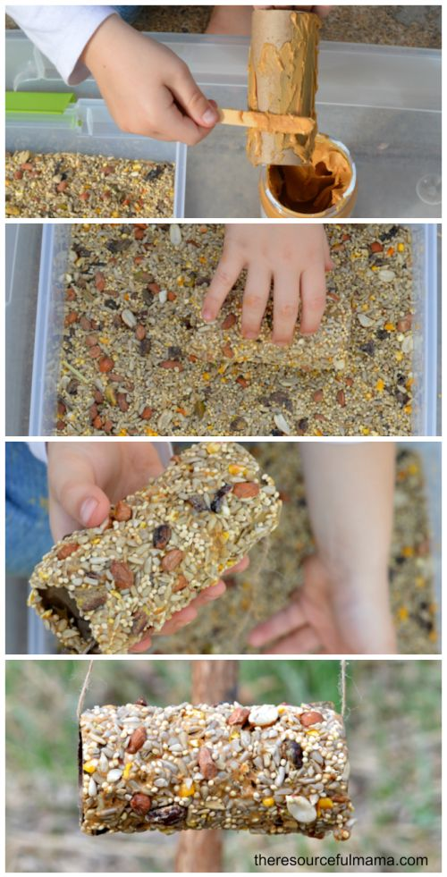

**Reuse project**

* Use clothing left behind to do art projects
  + Produce bags from t-shirts
  + Cut into strips and wrap around frames
* Bring recycled materials from the cafeteria and home for crafts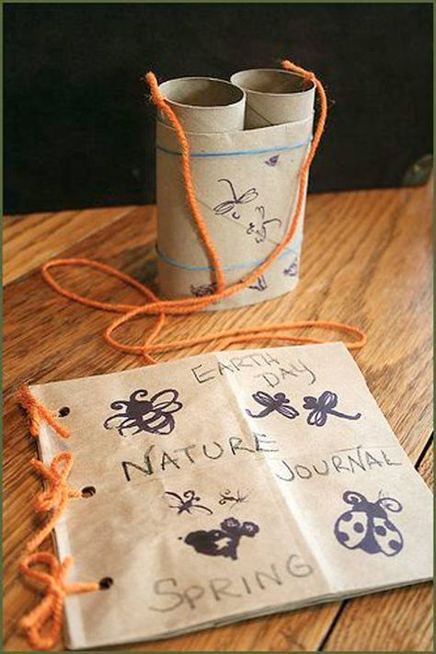
  + Bird feeders from empty milk cartons
  + Paper towel and toilet paper roll crafts
    - Binoculars
    - Bird feeders
  + K-cup seed starters

**Lesson plan**

* Information on how much clothing gets thrown away every year
  + Stats of how much clothing was in lost and found at the school if available
* Reduce, Reuse, Recycle video and questions <https://www.youtube.com/watch?v=OasbYWF4_S8> (video by Happy Learning English © 2016)
  + Why is it important to reuse items?
  + What is an item that you reuse at home or school? 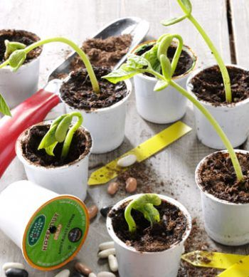
  + Where does reuse come in the waste hierarchy?
* Compost questions
  + How is food reused?
  + What food can be composted?
  + What things do you think would not break down?
  + What ingredients are needed to make a nutrient-rich soil?
* Sample craft ideas
  + Toilet Paper Roll Bird Feeder
  + Toilet Paper Roll Binoculars & Journal from Recycled Materials
  + K-cup Seed Starter